|  |  |
| --- | --- |
| **Take Home Case** | Description: LogoBINUS-University |
| *Web Design* |
| **Periode Berlaku** Semester Ganjil 2022/2023  ***Valid on*** *Odd Semester Year 2022/2023* | **Software Laboratory Center**  **Assistant Recruitment 23-1** |

## Materi

*Material*

* Website Prototype
* HTML
* CSS
* Javascript
* jQuery
* HTML5

## Soal

*Case*

**JeTe Knight**

**JeTe Knight** is an action-adventure video game developed and published by independent studio **Amigo**. It was released in 2017 for Microsoft Windows, macOS, and Linux, and was later released for the Nintendo Switch, PlayStation 4, and Xbox One.

In the game, players control a small, silent knight on a journey to uncover the mysteries of the abandoned insect kingdom of Hallownest. You as a intern on **Amigo studio** asked to make a demo game to the introduction **JeTe Knight** to the worldwide.

* **Prototype**
* Ensure that the website prototype is **exactly the** same with the JeTe Knight website. Consider the **color**, **layout**, and **consistency** when designing the prototype.
* Make sure to utilize **Figma’s features** when creating the **prototype**, such as **color styles**, **components**, **effects**, **variants & interactive component**, and **navigation**. You must create reusable item (button, input text, etc.) and **interactive component** (hover, click, etc.) using **component** and **variant**.
* Use the **asset** that have been provided for both **website** the **website prototype**.
* The website consists of two pages and two modal. They are **Home Page**, **Game** **Page, How to Play Modal**, and **Keyboard Mapping Modal**.
* **Navigation Bar**
* This navigation bar contains of 3 menus, **home**, **how to play**, **play for free**.
* If the **home**, and **how to play** menu get hovered, **underline text** will be showed up.
* Please make sure this **navigation bar** in exists in all page.

1. If userclickthe **home**, then:
   * Redirect to the **home page**
2. If userclickthe **how to play**, then:
   * Open the **modal**
3. If userclickthe **play for free**, then:
   * Redirect to the **game page**



Figure 1. Navigation Bar

* **Footer**
* This footer contains of 3 external link, **discord**, **facebook**, **twitter**,and **the footer text**.
* Please make sure if user **click** the **external link** they will **redirected** to the **external link**.
* The external link must be **upward** when **hovered**.
* Please make sure this **navigation bar** in **exists** in **all page**.



Figure 2. Footer

* **Home Page**
* This home page contains of 7 **sections**.
* The **7 section** contains of **Jumbotron**, **Description**, **Video Intro**, **News, Main Character, All Bosses, Official Soundtrack**.

1. **Jumbotron**
   * Display the **navigation bar** on the top of the jumbotron.
   * Use **video** from the assets for the **jumbotron background**.
   * Display **logo** on the **center** of the **jumbotron**.
   * Display the **latest news** on the **bottom** of the **jumbotron**, the **latest news** consists of **date, title**, and **gray line**. If the user **hovers** on the **latest news card,** then the **gray line** will be changed to **red line** and the **card** will be **larger**.
   * You need to create a **bottom black gradient** for the **jumbotron and the main background.**

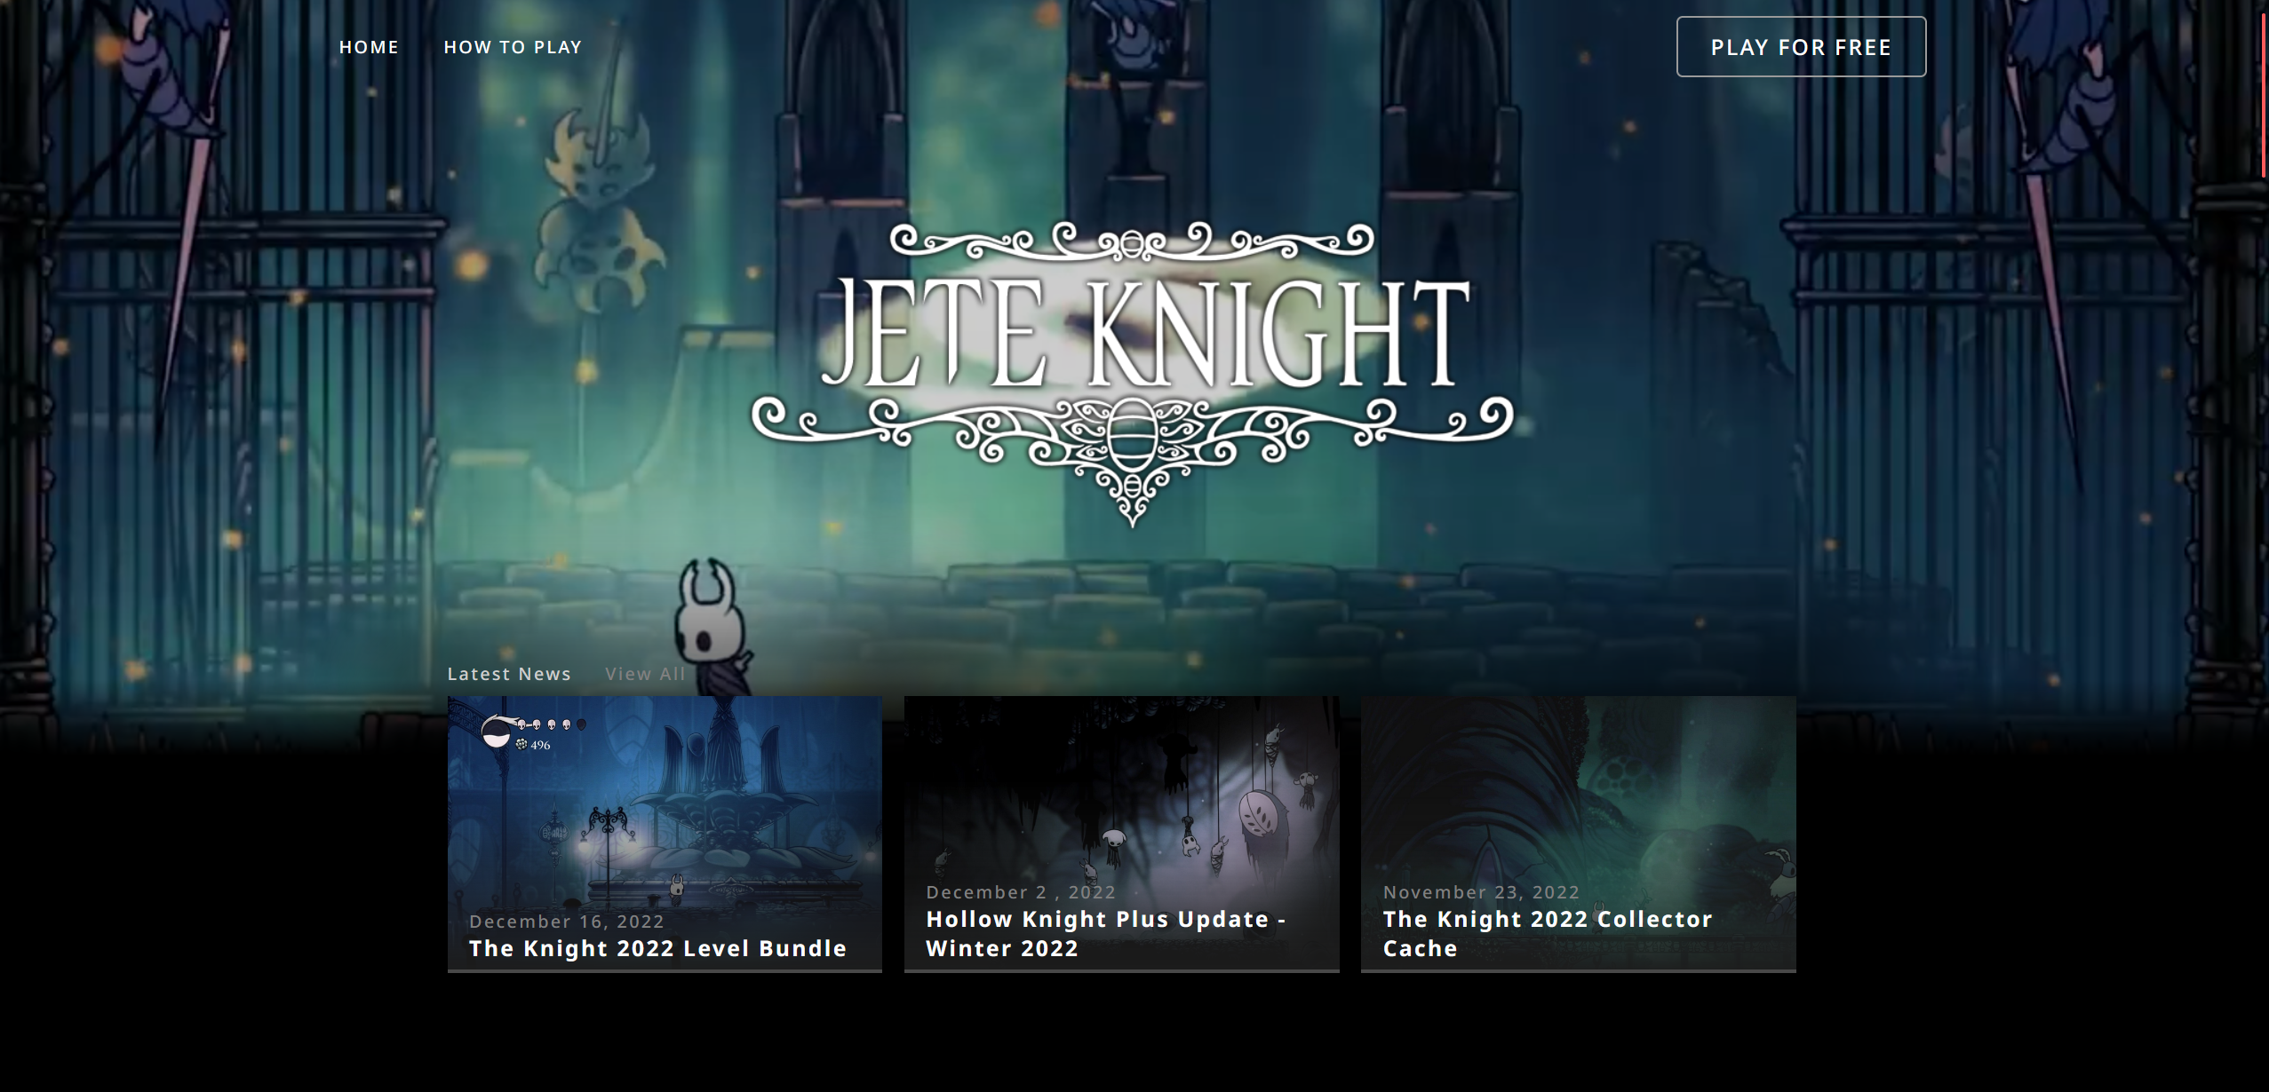

Figure 3. Jumbotron

1. **Description**
   * Display a **card** **carousel** consist of **description title**, **description text**, and **description image**.
   * **Add** a **three red circle** indicator to indicate current carousel index.
   * Don’t forget to **add left and right arrows** to **change** the card carousel.

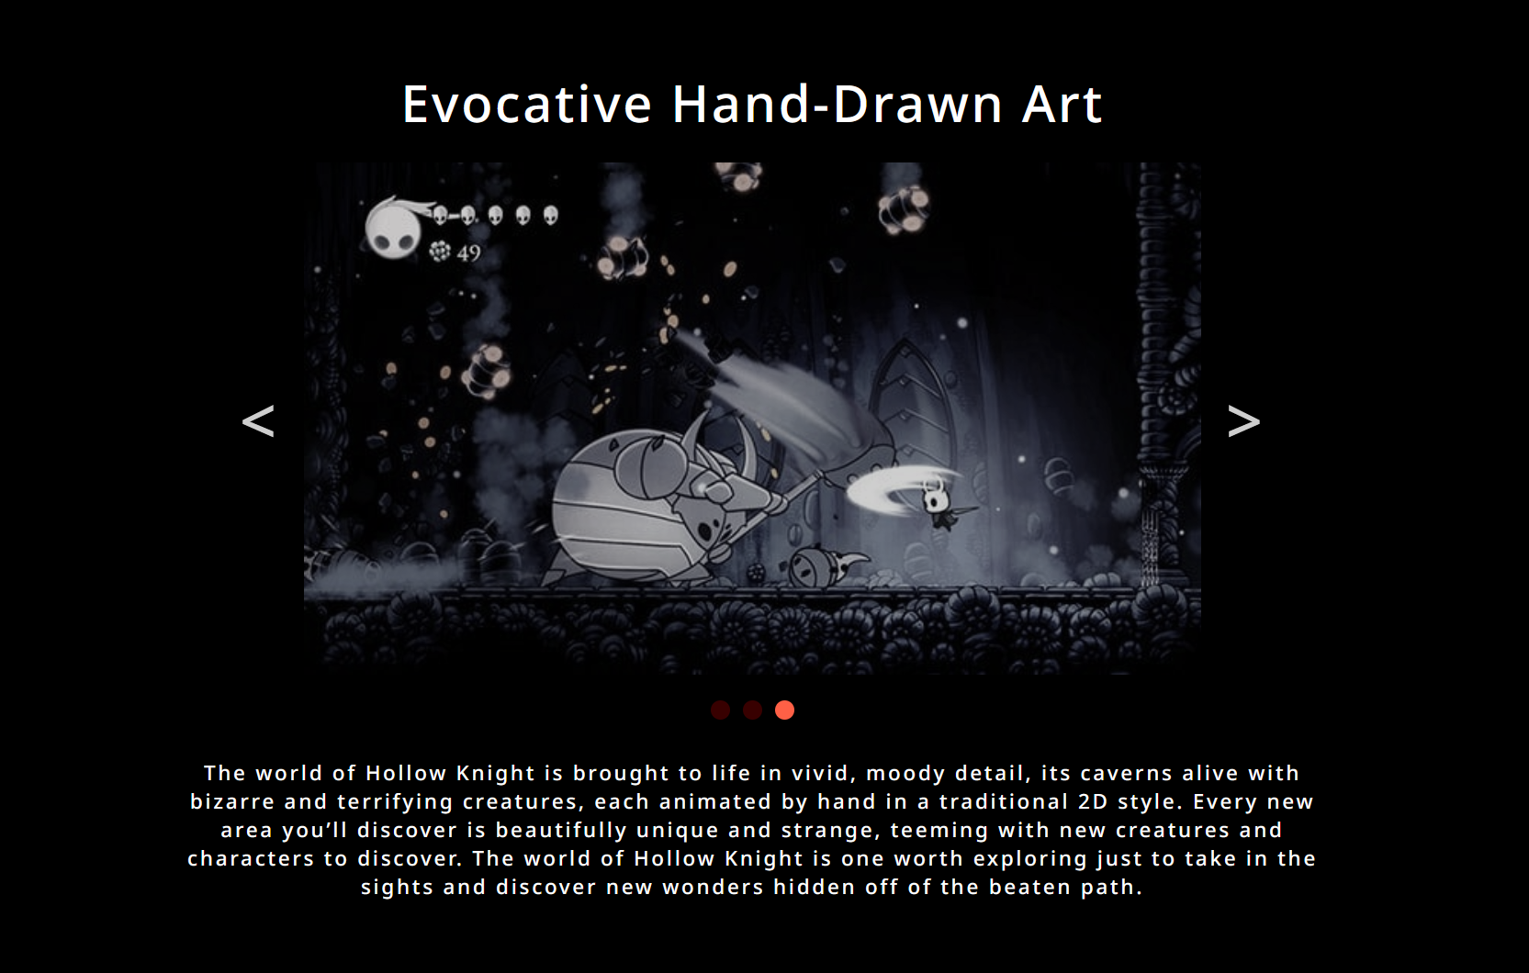

Figure 4. Description

1. **Video Intro**
   * Display a **YouTube video** using **iframe** from the link below
     + <https://www.youtube.com/watch?v=JuP47fRBsWg>

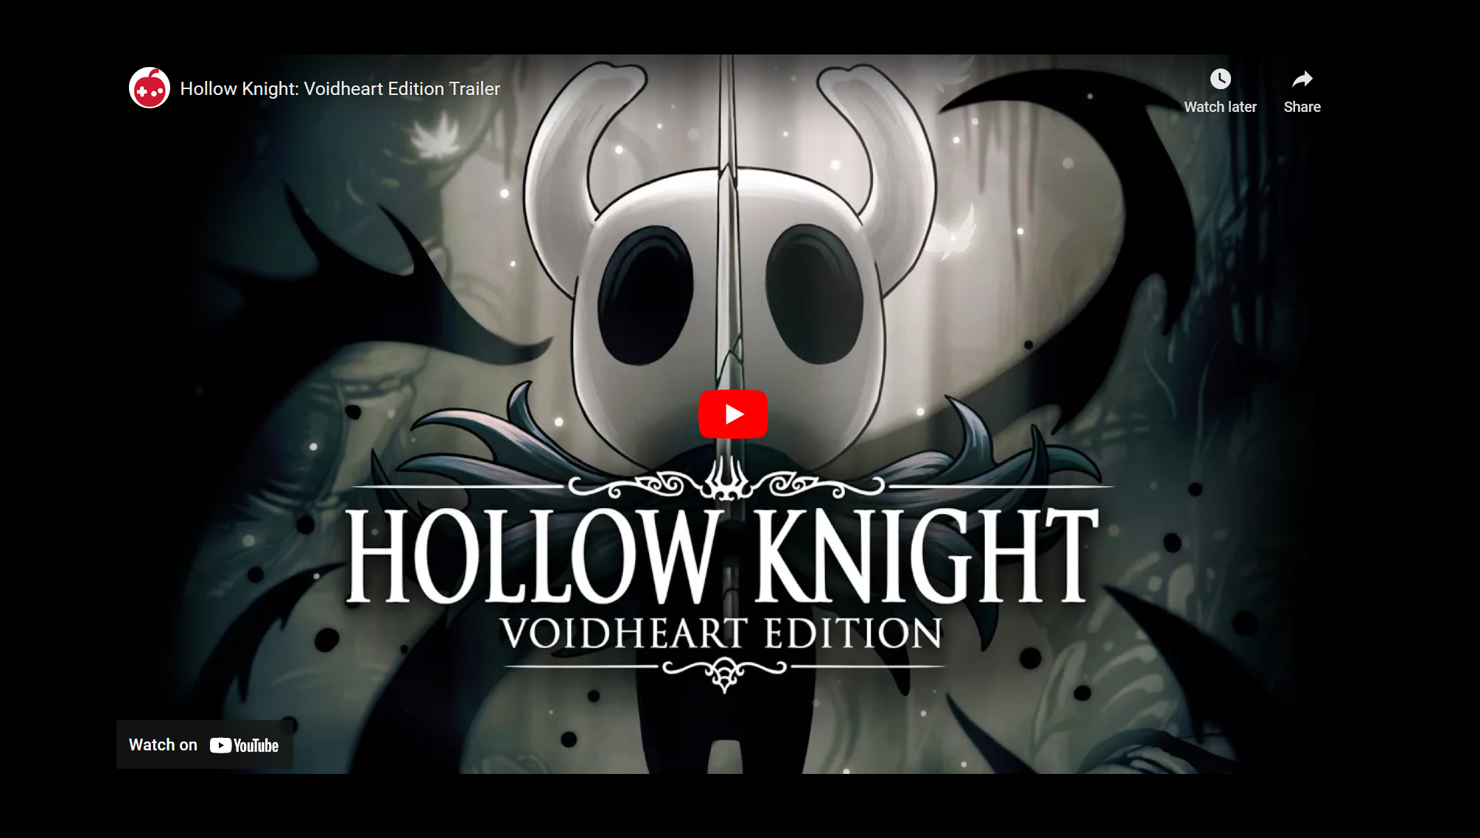

Figure 5. Video Intro

1. **News**
   * Display a **4-news card,** each news card contains of **news title**, **news text**, **news image**.

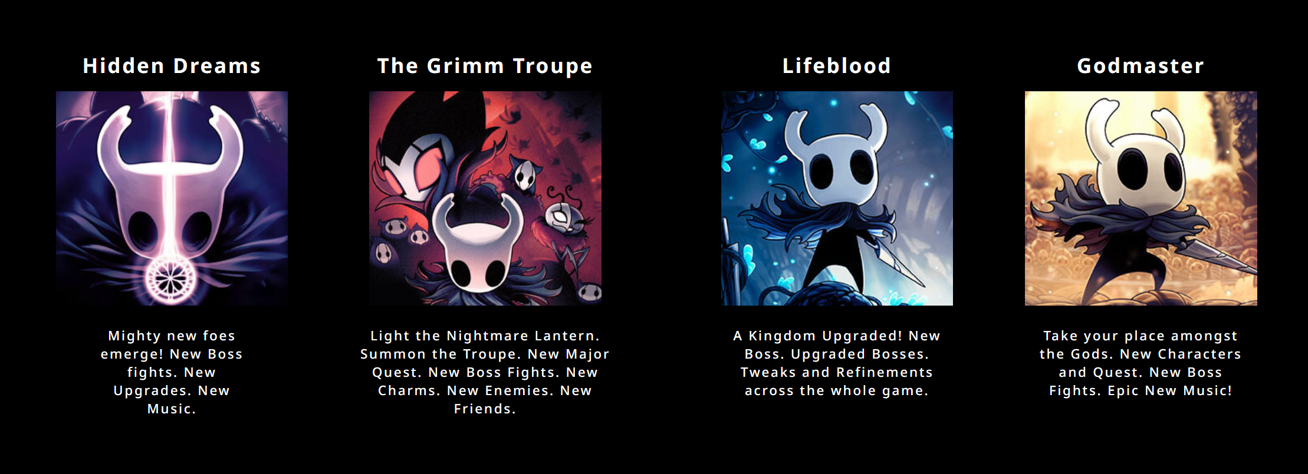

Figure 6. News

1. **Main Character**
   * Display **main character image**, **title**, **description**, and **button** to links to **external link** (**wikipedia)**

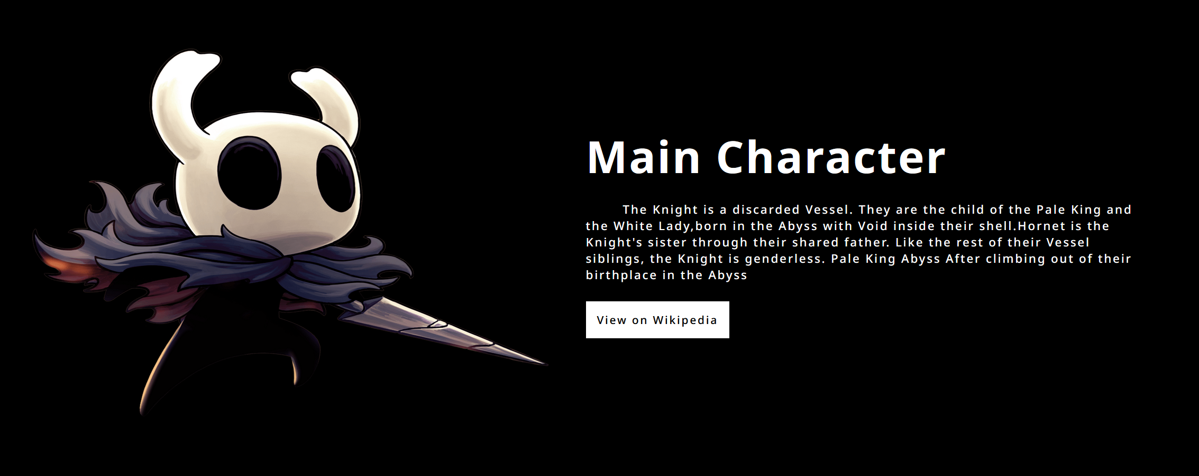

Figure 7. Main Character

1. **All Bosses**:
   * Display **all boss’s** cards in the 4 rows. Each card contains a **boss image**, and a **boss title**.
   * Please make sure the **Boss title** only **shows** if the card is hovered.
   * Don’t forget to make an **animation** where the **odd row** must **move** from **right to left** and the **even row** must move **from** **left to right**.

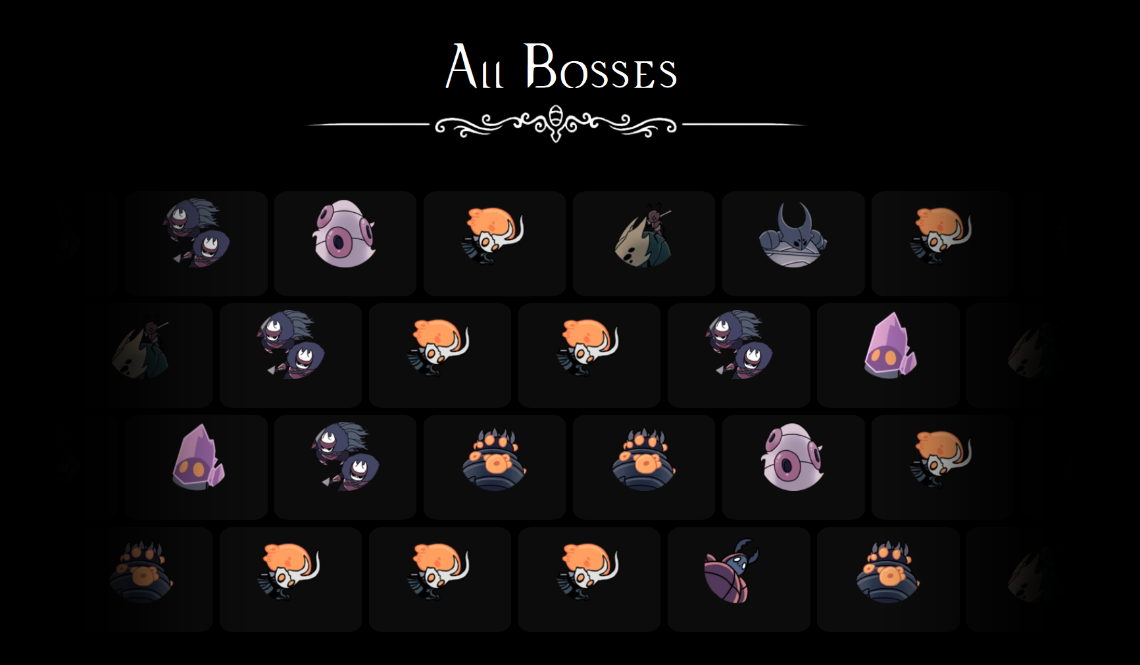

Figure 8. All Bosses

1. **Official Soundtrack**
   * On the left side of the container, display **title**, **description**, and a **button** to download the soundtrack. You can freely choose any audio asset in the folder to be downloaded.
   * On the right side of the container, displays the **soundtrack image**.

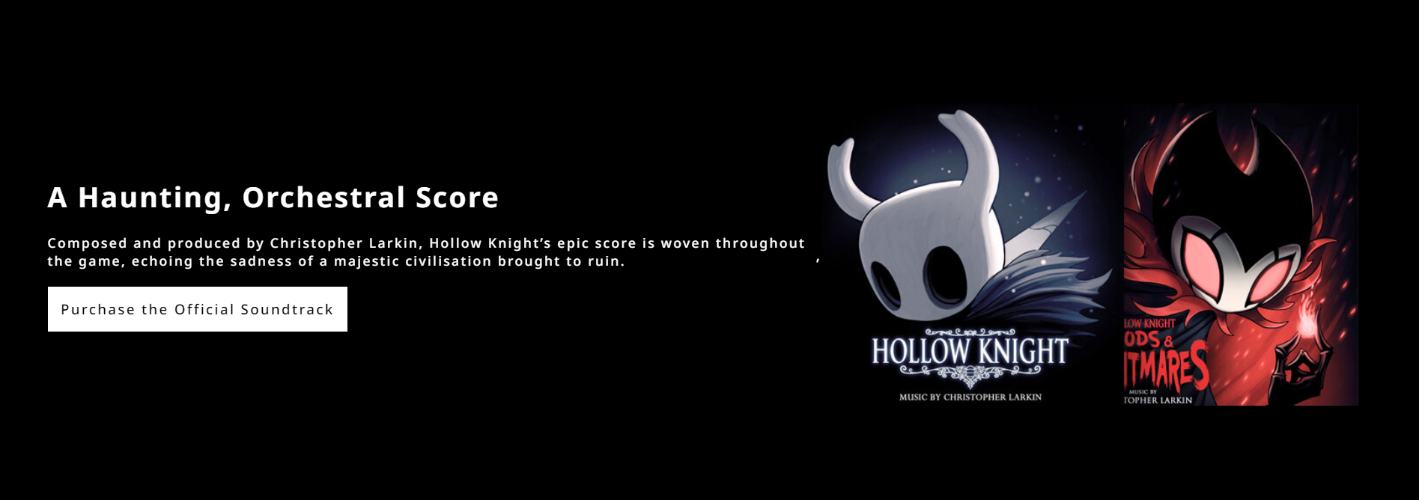

Figure 9. Official Soundtrack

* **Modal**
* This section is **appear** if the **user click** how to play in the navigation bar. Which mean this **section** **will appear** in **both home page and game page**.
* This section contain of **2 pages**:
* **How to Play**
* **Keyboard Mapping**.
* Display **current page** and the **max page** divided by **‘/’**.
* Display **X** Button to close the modal.
* Display **right**, and **left** cursor to change page in the modal.

1. If usershow **how to play** page, then:
   * Display all instruction text in the line using **<ul>** and **<li>**.
   * You need to add **‘#’** to the instruction text using **before selector css**.

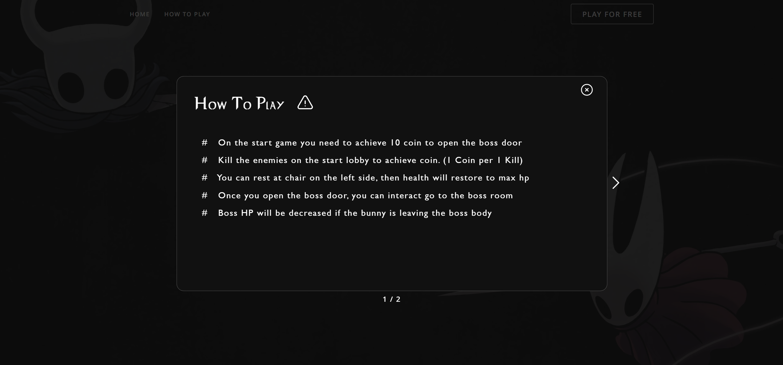

Figure 10. Modal

1. If user show **keyboard** **mapping** page, then:
   * Display a keyboard mapping **header**.
   * Display a **virtual keyboard**. Please color the **usefull key differently then others**.
   * If the user **press a key on their keyboard** and the **key is exists in the virtual keyboard**, **then darken the color** of the key by **300ms**.
   * If the user press the **usefull key** then display **the key description on the game**.

|  |  |
| --- | --- |
| **Key** | **Action** |
| **Esc** | Pause the game |
| **E** | Interact (used when go to the boss or the rest) |
| **S** | Player Dash |
| **F** | Active Fullscreen Mode |
| **Z** | Player Jump |
| **X** | Player Attack |
| **A** | Player Blast |
| **Space** | Interact (used when go to the boss or the rest) |
| **Arrow Up** | Player Jump |
| **Arrow Left** | Player Move Left |
| **Arrow Right** | Player Move Right |

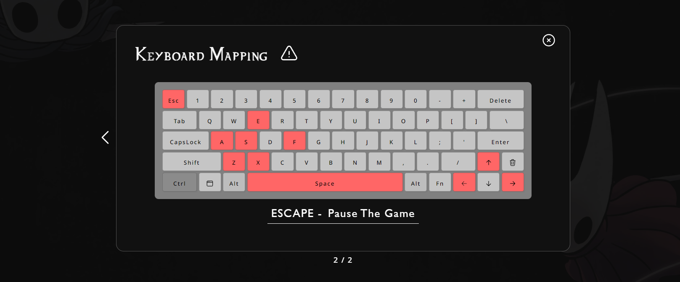

Figure 11. Keyboard Mapping

* **Game Page**
* Display the background given on the asset as the background of **game page**.

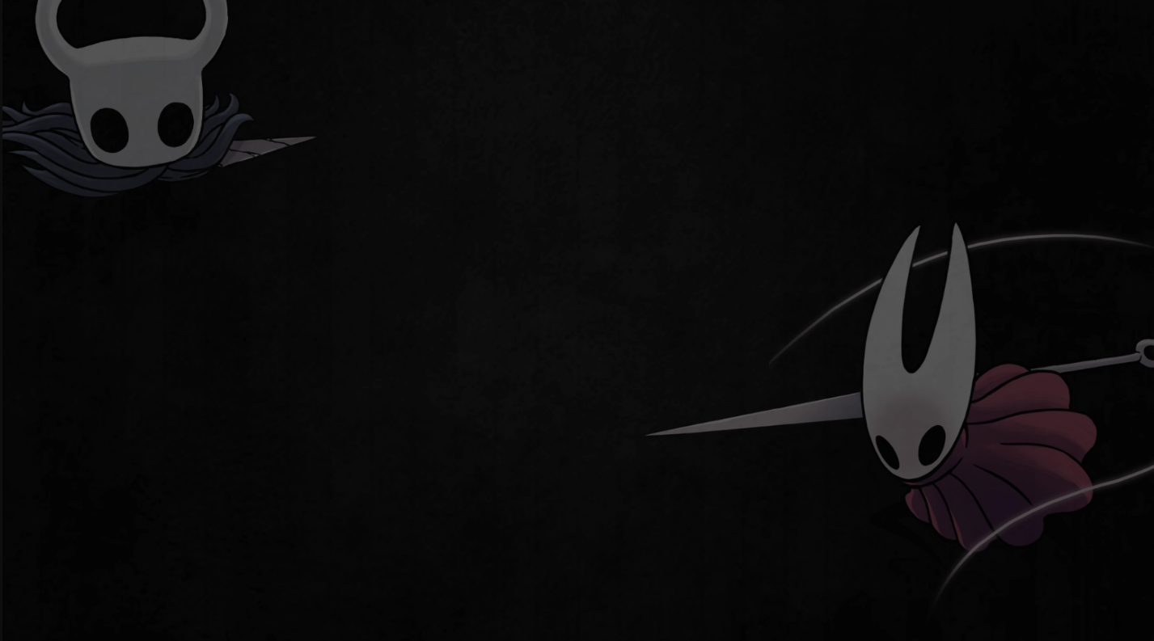

Figure 12. Background Game Image

* In the center of the page display the **game canvas** of the **demo game**.

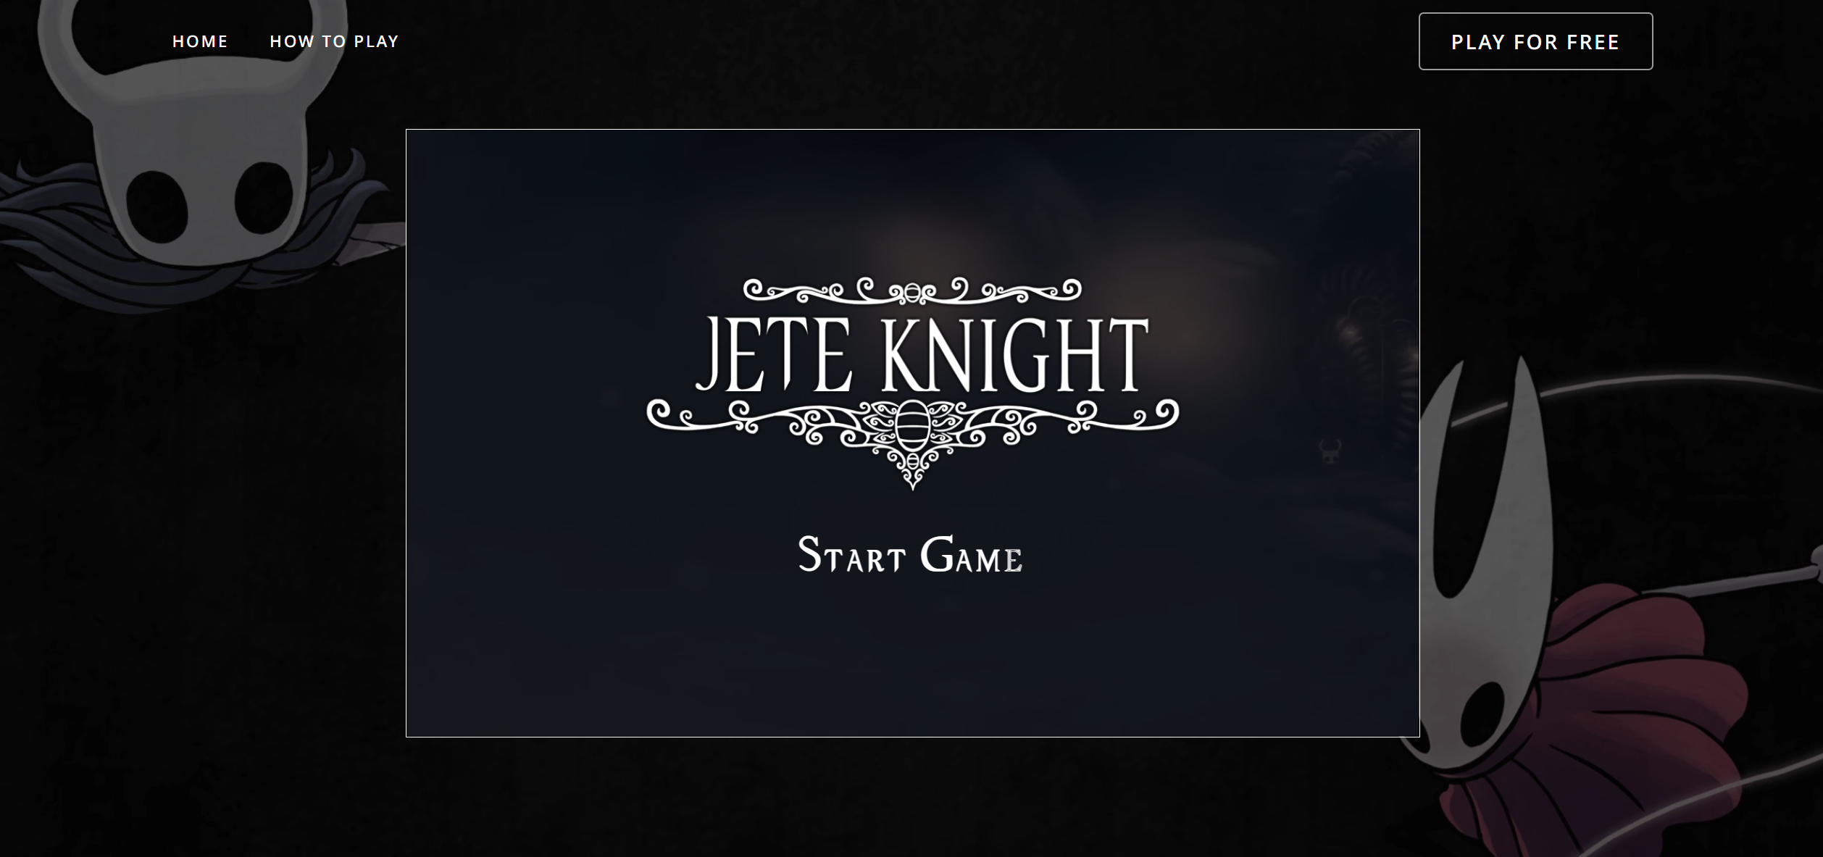

Figure 13. Game Page

* **Environment**
* You need to make custom **scroll bar** based on the **below image**.
* Below is the **recommended specification** for the **scroll bar**:

|  |  |
| --- | --- |
| **Thumb Color** | #FF5C5C |
| **Thumb Border Radius** | 10px |
| **Scrollbar Background** | #000000 (Black) |

* Don’t forget to give icon to the web. The icon url is, ‘**assets/icon.ico**’.
* Make a simple **responsive design** using **media query** and **meta viewport**. So the **web** still can be seen if user using different **view port**.

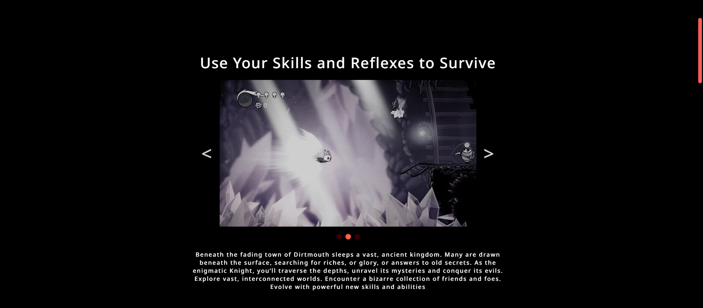

Figure 14. Custom Scrollbar

* **Demo Game**
* The game will be written using **HTML5 Canvas**.
* You should use **game developing concepts** and **best practices** such as main game loop, state,or any pattern that the game needs.
* You must calculate your own **delta times**.
* All the movement in the game needs to times by **delta times**, because it will made the game frame independent.
* Use **object-oriented programming concepts** to aid you in your development process.
* This is the recommended settings for the game:

|  |  |
| --- | --- |
| **Width** | 2000px |
| **Height** | 1200px |
| **Gravity** | 2650px/s x delta |

* The following Demo Game consist of :

1. Main Menu
   * Display **logo** and **start video**.
   * Display **Start Game** at the bottom of the logo.
   * If user click **start game** then the game will be start.

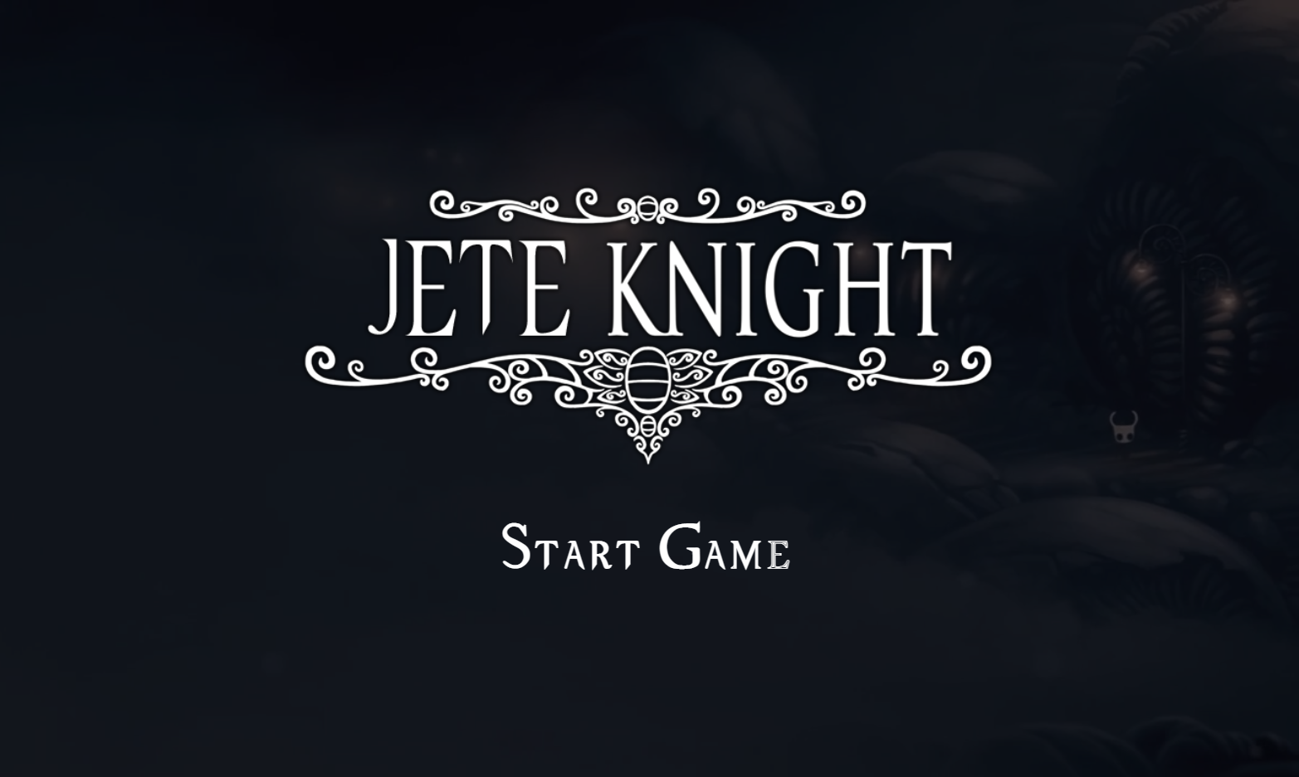

Figure 15. Start Game

1. Home Game
   * When the **game has started**, play the **home.mp3** on the asset folder.
   * **Start** to **calculate** **the FPS** (Frames Per Second) and **show it at the right of the game**.
   * Display **main background**.
   * Display **the ground**.
   * Display **the foreground**.
   * Display **the main character** in the center of the game.
   * Display **three platform** with minimum width is 300px. This is the recommended settings for the platform :

|  |  |
| --- | --- |
| **Platform 1** | X: 300, Y: 800, W: 400 |
| **Platform 2** | X: 900, Y: 700, W: 300 |
| **Platform 3** | X: 400, Y: 600, W: 300 |

* + Display **UI** **interface** for health & point.
  + Display **boss door** at the **right of the game**.
  + Every **10 seconds** **generate** **2 Crawlids** and **1 Vengefly**. For reduce so many crawlid and vengefly validates **if the alive Crawlid and alive Vengefly is more than 10**, then **don’t** **generate** another Crawlid and Vengefly.

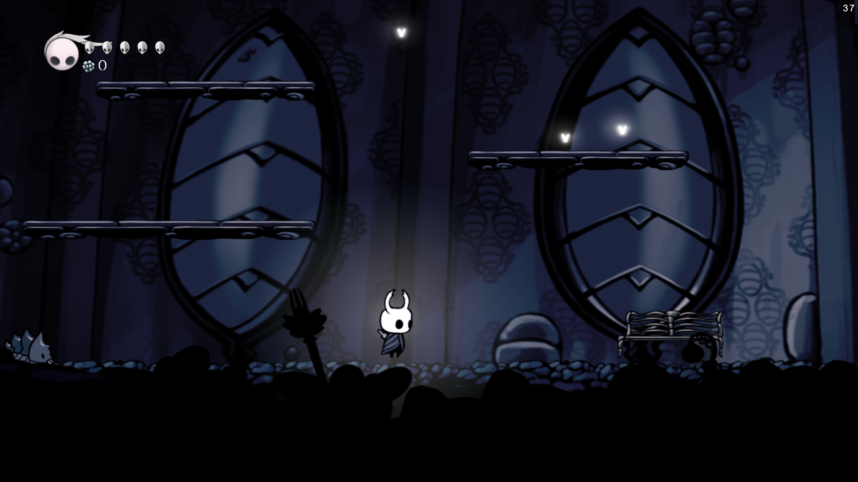

Figure 16. Home

1. Player
   * You wil need to **create** a **main character avatar**.
   * Please use all animation that **provided**. Below are the **animations** that will be used :

|  |  |
| --- | --- |
| **Idle** | /assets/game/hero/idle |
| **Attack** | /assets/game/hero/attack |
| **Dash** | /assets/game/hero/dash |
| **Dead** | /assets/game/hero/dead |
| **Hit** | /assets/game/hero/hit |
| **Jump** | /assets/game/hero/jump |
| **Splash 1** | /assets/game/hero/splash_1 |
| **Splash 2** | /assets/game/hero/splash_2 |
| **Walk** | /assets/game/hero/walk |
| **Blast** | /assets/game/hero/blast |
| **Blast Particle** | /assets/game/hero/particle/blast_particle |

* + Please use all **sounds** that provided. Below are the **sounds** that will be used :

|  |  |
| --- | --- |
| **Dash** | /assets/game/audio/hero_dash.wav |
| **Hit** | /assets/game/audio/hit.wav |
| **Jump** | /assets/game/audio/hero_jump.mp3 |
| **Attack** | /assets/game/audio/sword.wav |
| **Blast** | / assets/game/audio/hero_blast.wav |

* + Below is the **recommended specification** for the **character**:

|  |  |
| --- | --- |
| **Character Damage** | 1 |
| **Character Width** | 87.5 px |
| **Character Height** | 105 px |
| **Character Max Speed** | 300 px/s |
| **Character Jump Force** | 1100 px/s |
| **Character Dash Force** | 1500 px/s |
| **Character Dash Timeout** | 500 ms |
| **Character Max Health** | 5 healths |
| **Character Fade Timeout** | 3000 ms |
| **Character Knockback Power** | 200000 * delta |
| **Character Knockback Ressistance** | 1000 * delta |
| **Death Black Screen Timeout** | 3000 ms |

* + You need to render a **light** that always appear **behind the character**.
  + Below player will have **different states** depending on **what it is currently doing**. The states are listed as follow:
    - Dashing
      * **Character** will enter a **dashing state** if the player presses the ‘**s**’ **button**.
      * When **character is dashing**, play the **dashing animation**.
      * While **dashing**, **character** will have **brief invicibility**.
      * The **dashing** will be a **top priority**, which means the player **cannot do other actions** that will **cancel** **the dashing**.
      * **Play Dash sound** when **character is** **dashing**
    - Attack
      * **Character** will **enter attack state** if the **player presses** the **‘x’ button**.
      * When **Character** is **attacking**, play the **attacking animation**. There are **2 attack animation** that provided. You need to use **two of them periodically**.
      * When **attacking**, make a **splash particle** in **front of the character** is heading. **Use the splash particle** that **provided to make an animations**.
    - Hit
      * The game will pause for **0.5** **seconds** if it **collides** with the **enemy**.
      * Character will enter **hit** **state** for **3 seconds** if it **collides** with the **enemy**. And don’t forget to **render a hit particle** animations that provided.
      * In the **hit state,** please make sure the character won’t be hitted again **(invicible)**.
      * Character’s **HP will be decreased** by one if it got hit by the **enemy**.
      * Display character **fade in & fade out** periodicly when in the **hit state**.
    - Jumping
      * Character will enter **jumping state** if the player presses the **‘z’ button**.
      * When character **is in the air**, play the **jumping animation** that provided.
      * When character **jumps**, play the **jumping sound** that provided.
    - Death
      * Character will enter **death state** if the player HP below than zero.
      * Character will play **death animation** and the body will moving upward.
      * Don’t forget when the body is **moving upward** then, shake the character.
      * Render a **death message** for **3 seconds** after the **character** is **die**.
    - Blast
      * Character will enter **blast state** if the player presses the **‘a’ button**. Please make sure, this **state** only occurred if player **is grounded**.
      * When **blast is created** create and render a **blast** **particle**.
      * Create a **blast** that goes with the **direction** of the **character**. It’s mean if the **character is turn left** then blast **will go to the left**, and vice versa.

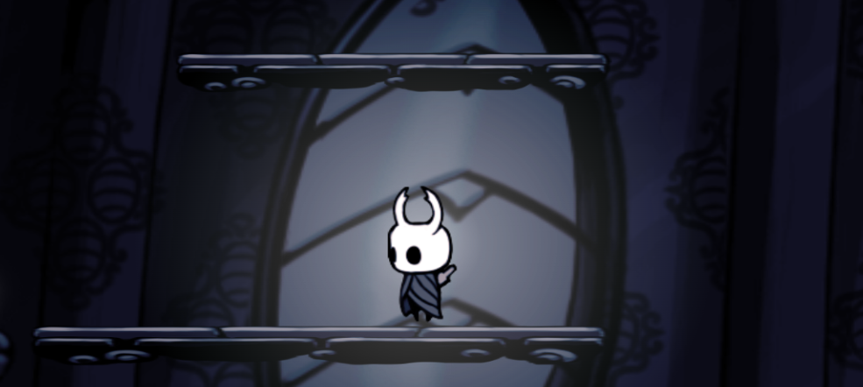

Figure 17. Main Character

1. Crawlid
   * You will need to create a **enemy** called Crawlid.
   * **Crawlid** will move **forward** from the currently direction.
   * If **Crawlid** collides with left corner canvas or right corner canvas. Crawlid direction will be changed.
   * Please use all animation that **provided**. Below are the **animations** that will be used :

|  |  |
| --- | --- |
| **Walk** | /assets/game/crawlid/walk |
| **Die** | /assets/game/crawlid/die |

* + Please use **sounds** that provided. Below are the **sounds** that will be used :

|  |  |
| --- | --- |
| **Death** | /assets/game/audio/crawlid_death.wav |

* + Below is the **recommended specification** for the **Crawlid**:

|  |  |
| --- | --- |
| **Crawlid Speed** | 24 px/s |
| **Crawlid Max Speed** | 50 px/s |
| **Crawlid Width** | 70 px |
| **Crawlid Height** | 70 px |

* + Crawlid only had **1 HP** that will automatically die, if the player hitted.
  + If **Crawlid die** there’s will be a knockback distance and death animation.
  + Don’t forget to add coin to the player if the **Crawlid** has die.

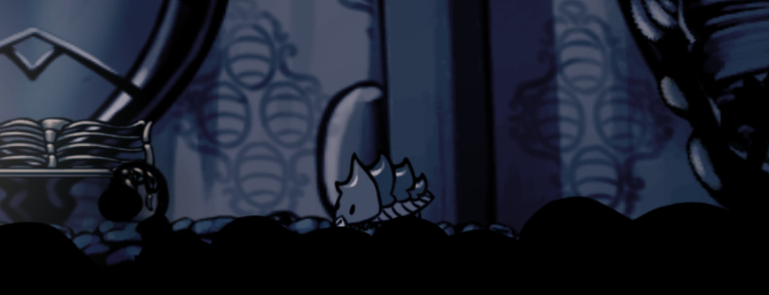

Figure 18. Crawlid

1. Vengefly
   * You will need to create a **enemy** called Vengefly.
   * **Vengefly** will fly **forward** from the currently direction.
   * If **Vengefly** collides with left corner canvas or right corner canvas. **Vengefly** direction will be changed.
   * **Vengefly** have ability to chasing main character if in the **check radius**. If **vengefly** is chasing then, increase the **max speed** to **100 px/s**.
   * Please use all animation that **provided**. Below are the **animations** that will be used :

|  |  |
| --- | --- |
| **Fly** | /assets/game/boofly/fly |
| **Die** | /assets/game/boofly/die |

* + Please use all **sounds** that provided. Below are the **sounds** that will be used :

|  |  |
| --- | --- |
| **Death** | /assets/game/audio/venge_death.wav |

* + Below is the **recommended specification** for the **Vengefly**:

|  |  |
| --- | --- |
| **Vengefly Width** | 70 px |
| **Vengefly Height** | 70px |
| **Vengefly Speed** | 24 px/s |
| **Vengefly Max Speed** | 50 px/s |
| **Vengefly Max Chase Speed** | 100px/s |
| **Vengefly Check Radius** | 400px/s |

* + Vengefly only had **1 HP** that will automatically die, if the player hitted.
  + If **Vengefly die** there’s will be a knockback distance and death animation. Make sure that **vengefly** will **falldown** if they die.
  + Don’t forget to add coin to the player if the **Vengefly** has die.

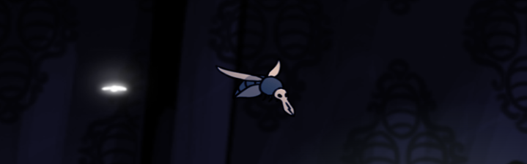

Figure 19. Vengefly

1. Rest
   * You will need create a **bench** for main character can rest.
   * If the bench is **colliding**, then user can rest if they press **‘e’** or **‘space’** button. Don’t forget to create **Rest** text at the **bottom right** of the **canvas**.
   * If user is **interact with the** **rest**, then **fade** the **white screen for *300ms***, then make the character **health** into **max health**.

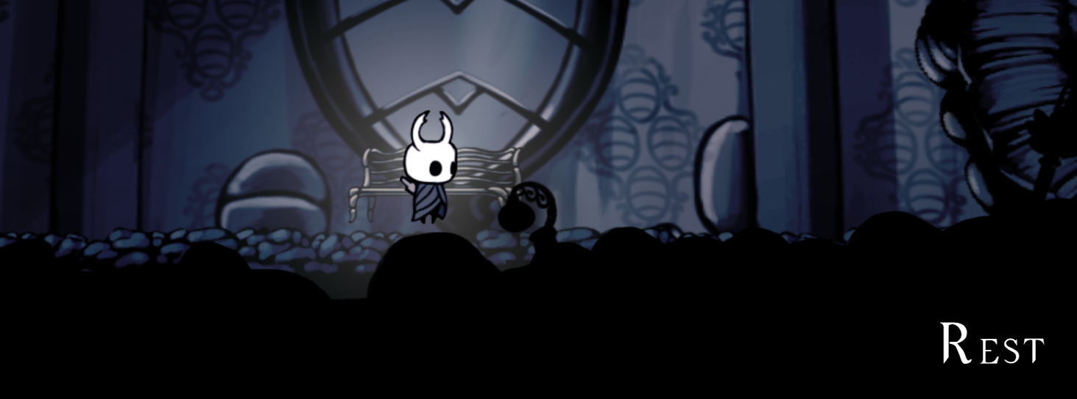

Figure 20. Rest

1. Splash
   * The splash are the **first damage dealer** of the **main character**.
   * There are **2 splash animations** that provideds. Please used it **periodically**.
   * If the **splash** is colliding with enemy, then enemy will get **hit**. And render the **hit particle**. Don’t forget to decrement **enemy HP** by player **damage**.
   * Below are the **animations** that will be used:

|  |  |
| --- | --- |
| **Splash 1** | /assets/game/hero/splash_1 |
| **Splash 2** | /assets/game/hero/splash_2 |
| **Hit Particle** | /assets/game/particle/hit |

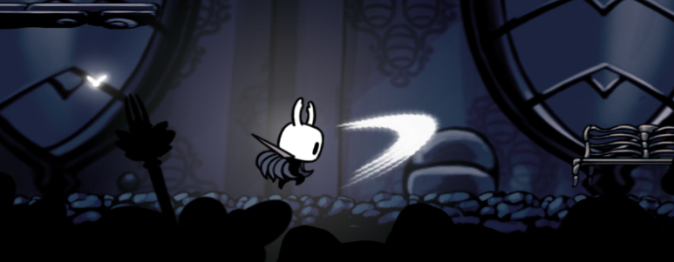

Figure 21. Splash

1. Blast
   * The blast are the **second** **damage dealer** of the **main character**.
   * Blast will always go **forward**.
   * Validate if blast is **bounding the canvas**, then **remove it**.
   * If **blast collides** with the enemy, then enemy will get **hit**. And render the **hit particle**. Don’t forget to decrement **enemy HP** by player **damage**.
   * Please use all animation that **provided**. Below are the **animations** that will be used :

|  |  |
| --- | --- |
| **Blast** | /assets/game/particle /blast |

* + Below is the **recommended specification** for the **blast**:

|  |  |
| --- | --- |
| **Blast Speed** | 3000 px/s |
| **Blast Max Speed** | 3000 px/s |
| **Blast Timeout** | 10000 ms |

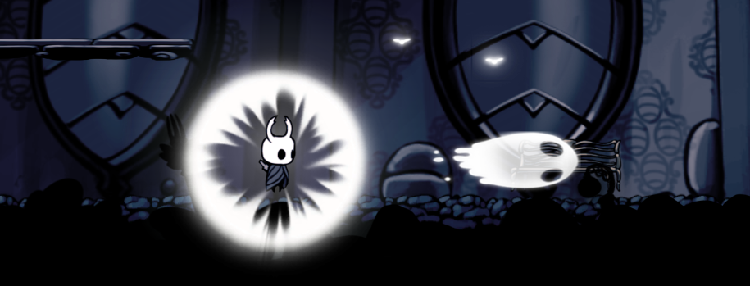

Figure 22. Blast

1. False Knight
   * You will need to **create a boss avatar** called False Knight.
   * If **boss** hitted when he was not in the stun state, then player damage will be afftect to the **boss armor**.
   * Below player will have **different states** depending on **what it is currently doing**. The states are listed as follow:
     + Idle
       - In this state, boss will waiting for **1 second** to generate another state.
       - There are **2 state** can be **generated** which is **jump state** and **attack prep** **state** and the possibility is **50 : 50**.
     + Attack Preparation
       - **Boss** direction will automatically follow the player position. It’s mean if the **player** is in **the left side of the boss**, then **boss** will **face up** to the **left side**, and vice versa.
       - In this state, boss will waiting for **3 seconds**. Until go to the next state **Attack State**.
     + Attack
       - In this state, boss will **hit the ground** with **provided animations**.
       - Make the boss hit **3x times** to hit the ground then boss will be going to **idle** state.
     + Jump
       - **Boss** direction will automatically follow the player position. It’s mean if the **player** is in **the left side of the boss**, then **boss** will **face up** to the **left side**, and vice versa.
       - The recomended boss jumping force is **1500**, and have a static horizontal speed by **1000px/s**.
     + Land
       - Boss said to be **landed** if he **was in the jumping state**, and **grounded**.
     + Stun
       - This state can occur if the **boss armor** is **below** or **equal than zero**.
       - If their’s **getting hit** by **player** **decrement** the **boss hp** by **player damage**.
       - Don’t forget to **validate** if the **hp is below or equal than zero**, then the boss will going to **death state**.
     + Death
       - In this state, the **ghost** will be out of the boss body, and start the **credit scene**.
   * Below is the **recommended specification** for the **Boss**:

|  |  |
| --- | --- |
| **Boss Width** | 550 px |
| **Boss Height** | 400 px |
| **Boss Attack Preparation** | 24 px/s |
| **Boss Attack Times** | 3x times |
| **Boss Jump Force** | 1500 px |
| **Boss Health** | 30 health |
| **Boss Armor** | 10 armors |
| **Bos Jump Speed** | 1000 px |
| **Boss Death Speed** | 800 px |
| **Boss Stun Time** | 5000 ms |
| **Boss Max Speed** | 300 px/s |

* + Please use all animation that **provided**. Below are the **animations** that will be used :

|  |  |
| --- | --- |
| **Attack** | /assets/game/boss/attack |
| **Attack** **Preparation** | /assets/game/boss/attack_prep |
| **Die** | /assets/game/boss/die |
| **Ghost** | /assets/game/boss/ghost_die |
| **Idle** | /assets/game/boss/idle |
| **Jump** | /assets/game/boss/jump |
| **Land** | /assets/game/boss/land |
| **Stun** | /assets/game/boss/stun |

* + Please use all **sounds** that provided. Below are the **sounds** that will be used :

|  |  |
| --- | --- |
| **Attack Preparation** | /assets/game/audio/false_knight_attack.wav |
| **Jump** | /assets/game/audio/false_knight_jump.wav |
| **Land** | /assets/game/audio/false_knight_land.wav |
| **Attack (Strike)** | /assets/game/audio/false_knight_strike.wav |

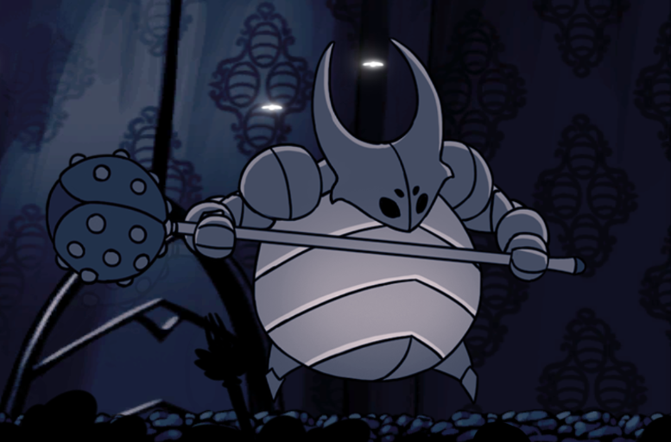

Figure 23. False Knight

1. Boss Door:
   * Boss door will have 2 states, **closed, and open**.
   * **Closed state** will be the **default state** of the game. It’s mean when **user first time start the game** the **boss door will closed**.
   * The **boss door** will open if the **coin** is **more than 10**. Make an animation that door will move from **top** to **bottom** and the **light** will **shine** from the middle of the door. Please validate **if the boss door** **still animated player** can’t interact / go to the boss room.
   * If the **player** is **collide** with the **boss door**, then :
     + Show text ‘**Space**’ To Interact to the **bottom left** of the canvas.
     + If the user press ‘**Space**’ then user will **go to the boss room**.

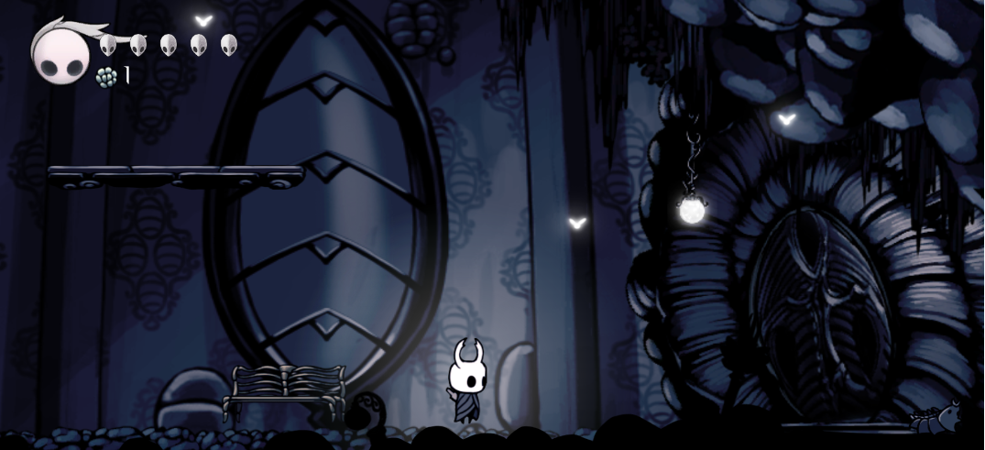

Figure 24. Closed Boss Door

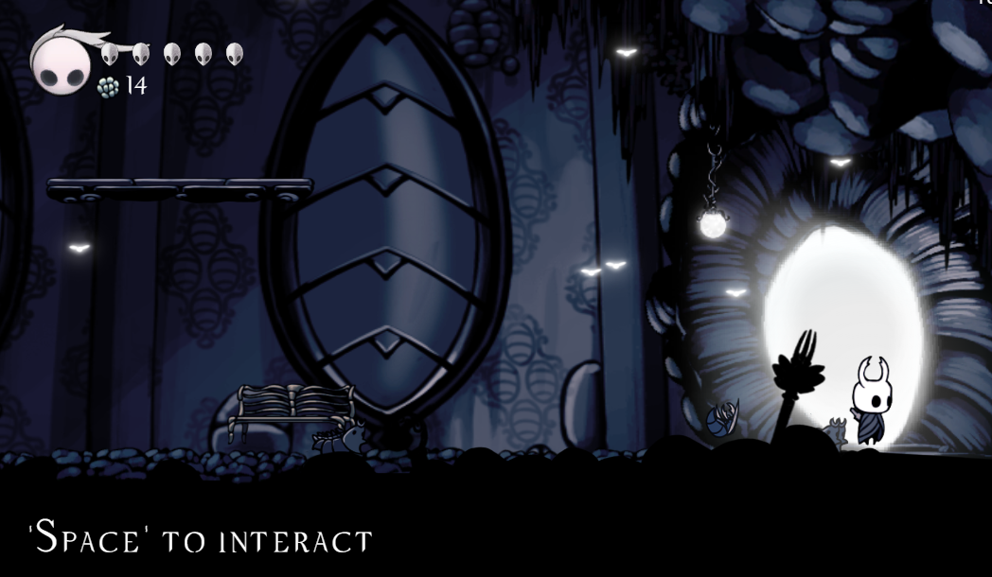

Figure 25. Opened Boss Door

1. Boss Room
   * Change the **background** with boss room background.
   * Play the **boss.mp3** on the asset folder.
   * **Spawn** the **boss** at the **center** of the game.
   * **Teleport** the **character** to the **left corner** of the game.

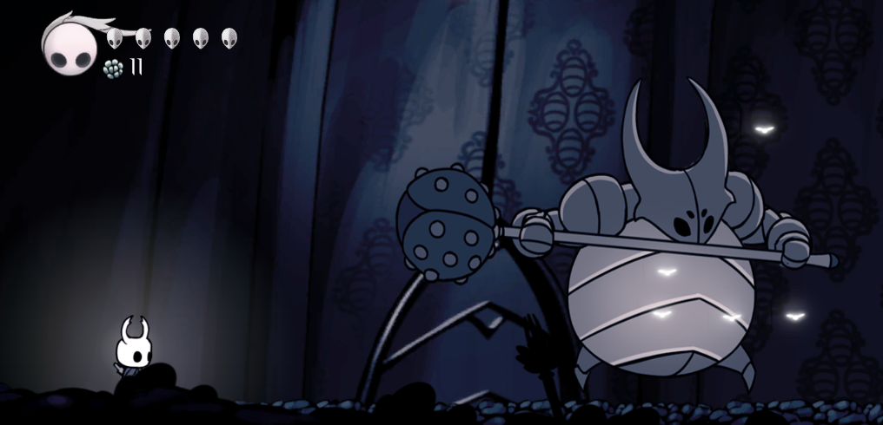

Figure 26. Boss Room

1. Player Bar
   * There are two main component in the bar :
     + Point
       - This point is **represent** current player point.
     + Health Symbol
       - This symbol **represent player health**. If the player health is **5** then, display **5 health symbol**. If there is any chance the **player getting hit**, then the **health symbol will be decrease**.

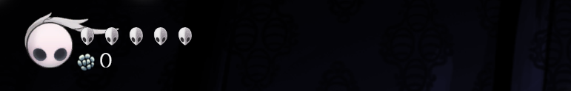

Figure 27. Player Bar

1. Pause Game
   * There are four main button in the pause game :
     + Continue
       - If user click **continue**, then the **remove the pause UI**, and **resume the game**.
     + Show FPS
       - If user **click show FPS button**, it will **toggle FPS** **counter** **visibility** in the **right top corner** of the canvas
     + Volume
       - You can adjust **Game Volume**, by **dragging the input**. Please make sure that the far **left range is the most smallest volume**, and vice versa.
     + Exit Game
       - If user click show Exit Game, user need to **back to the menu**. You can freely use **whatever algorithm** to **back to the menu**.

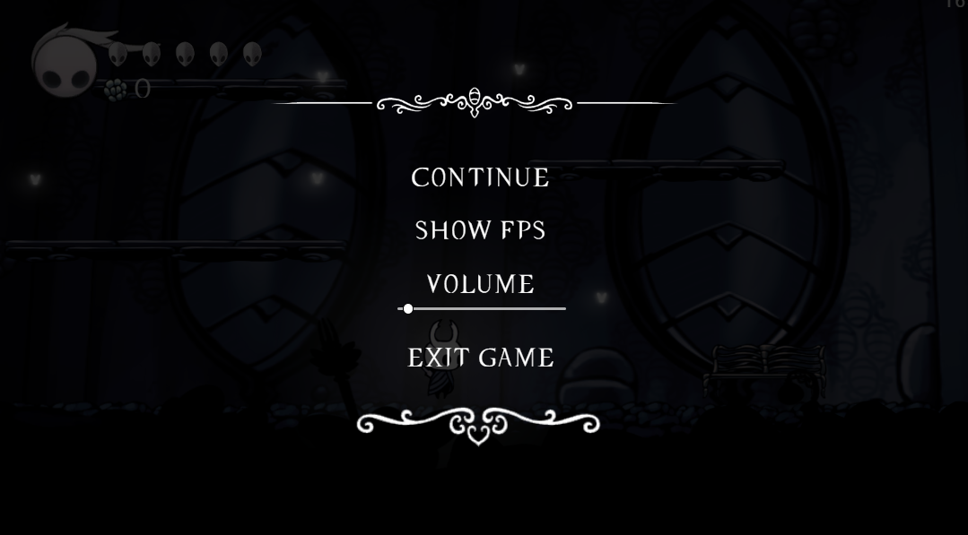

Figure 28. Pause Game

1. Environtment
   * There is a some layer you needs to build in this game :
     + Main Background
       - **Main background** have ability to move by **10px/s** when user is moving. It’s mean when **user is moving to the left**, then **background will move from left to the right**, and **vice versa**.

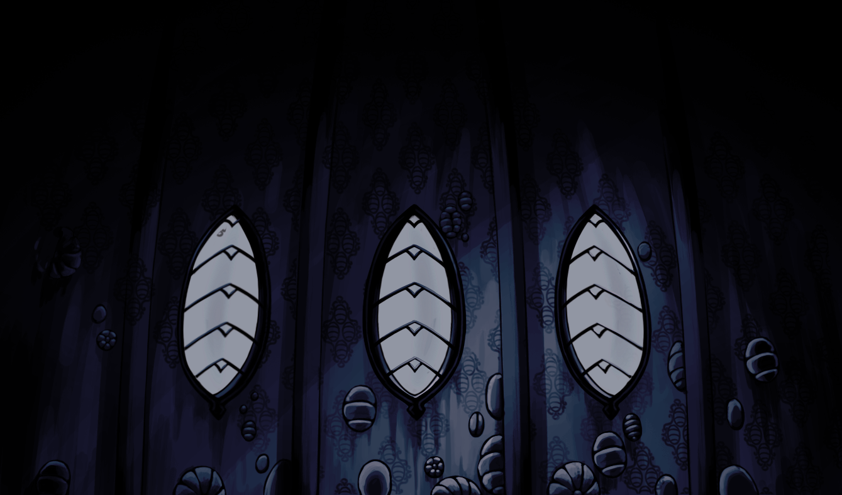

Figure 29. Home Background

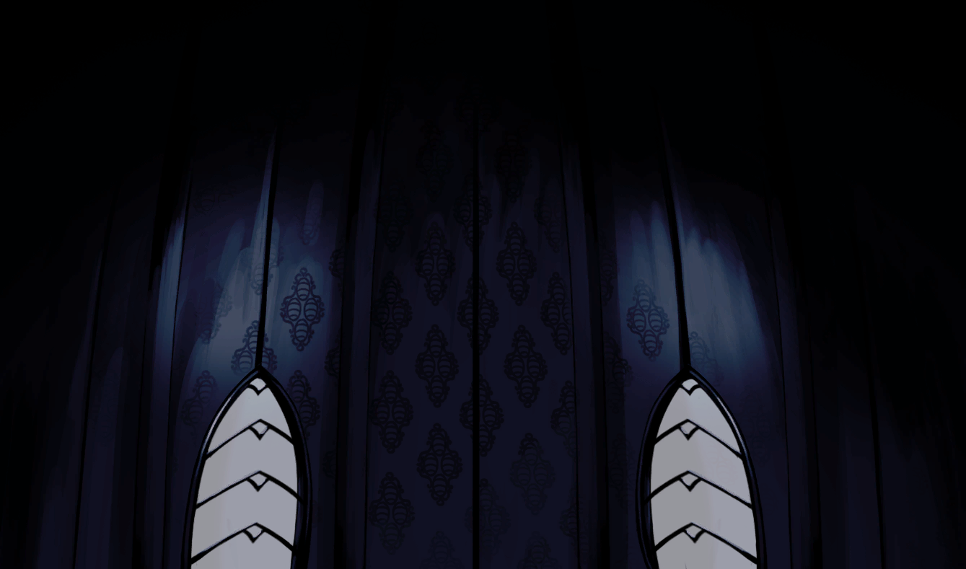

Figure 30. Boss Background

* + - Foreground
      * **Foreground** have ability to move by **30px/s** when user is moving. It’s mean when **user is moving to the left**, then **foreground will move from left to the right**, and **vice versa**.

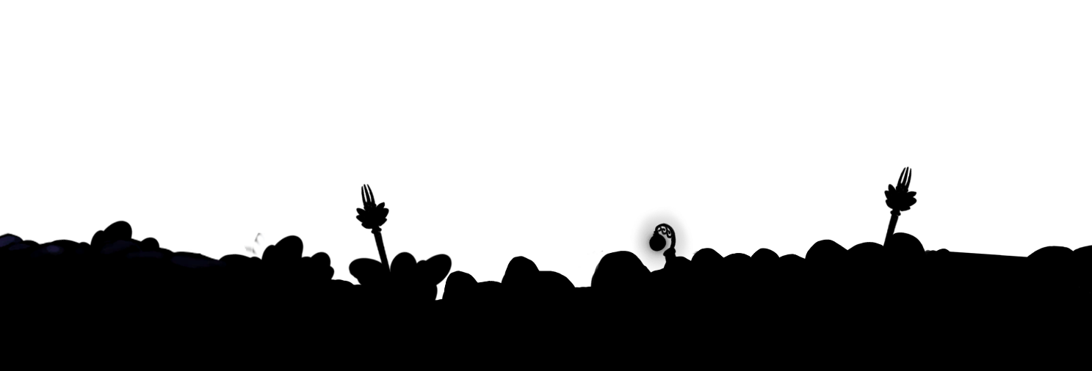

Figure 31. Foreground

* + - Ground
      * Ground is an **object** that **can be collided**. It’s mean when **player step on the ground** player **will not fall** down to the canvas.
      * You need to **make the ground with the given asset**, please make sure the **ground doesn’t have a gap**.

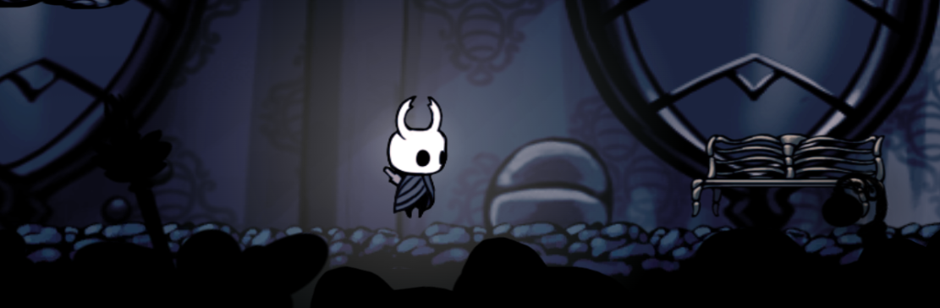

Figure 32. Ground

* + - Flies
      * To prevent the game getting to **dark**, **generate 15 flies** in **random position** on the **canvas**. Please make sure if the flies **cannot be on the bottom of the ground**.

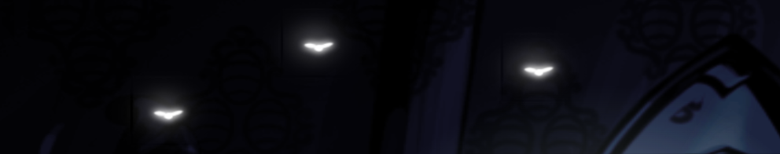

Figure 33. Flies

1. Credit Scene
   * This **credit scene** is occur if **player** has **defeat the boss**.
   * **Pause / turn down** all current played audio.
   * Play the **victory.mp3**
   * There’s will be a **fade in black screen** for **5 seconds**.
   * Create **text credit animation** that will move from bottom to up.
   * If all text credit is showed then, show the **video** that’s used in **jumbotron** **(header.mp4)**. And don’t forget to put **end.png** at the middle of the video.

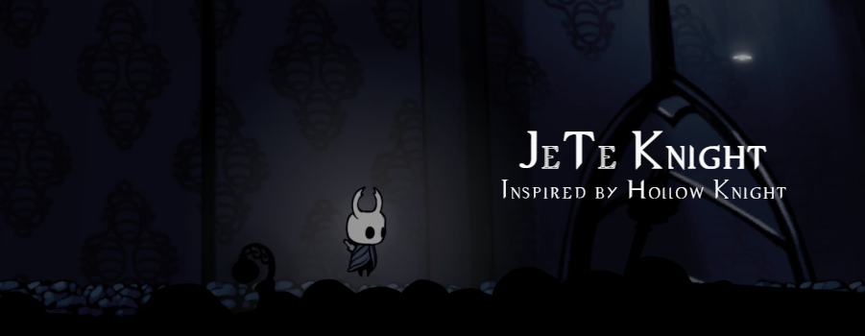

Figure 34. Credit

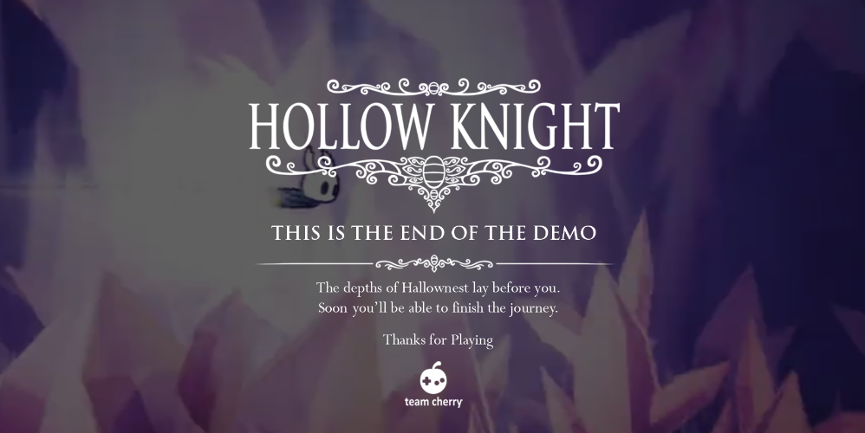

Figure 35. Video After Credit

|  |  |
| --- | --- |
| **Component** | **Score** |
| Home | 20 |
| Modal | 15 |
| Main Game Environment | 10 |
| Character | 20 |
| Enemy | 15 |
| Player Bar & Pause | 10 |
| Scene & Credit | 5 |
| Prototype | 10 |

Please run the EXE file to see the sample program.